MEDITATION HOUR AT THE HEALING GARDENS
With Bhante Bhaddiya
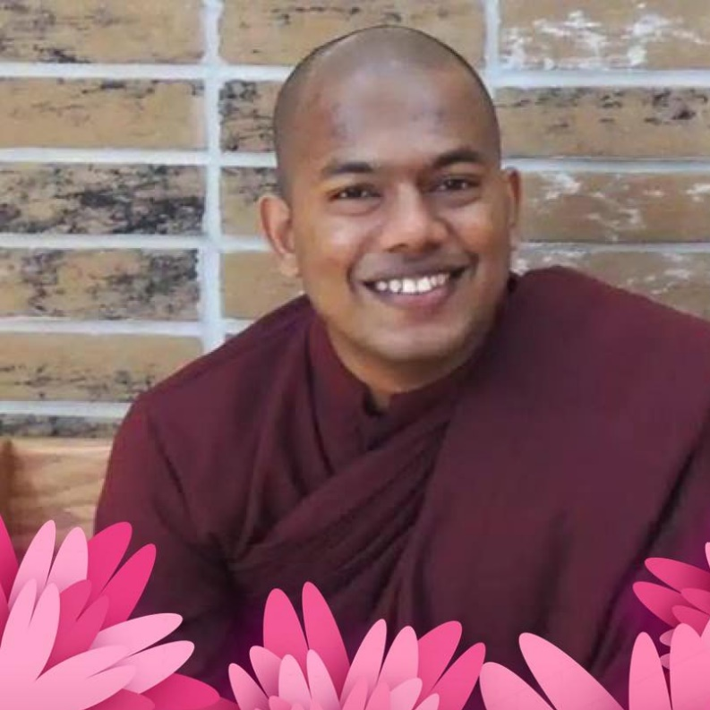
Join Bhante Bhaddiya, Buddhist monk from Sri Lanka for a one-hour event surrounded by the beautiful Healing Gardens at Stonehill Farm in St. Charles. Bhante will teach a loving kindness meditation, walking meditation in the gardens and an inspirational Dhamma talk.
DATE: SUNDAY AUGUST 12
LOCATION: 37W249 Dean St., St. Charles 60175
TIME: 2:00-3:00 (following 1:00 Yoga class with Nancy May)
Fee: $10 suggested donation for meditation Contact Nancy May to reserve your space for yoga and/or meditation 815-319-3500

